

Testing Document

PAT Phase 5 – Grade 12

Prepared by Marco de Sá

Maragon Mooikloof

20/9/2022

Table of Contents

1. Evaluation of Solution – against original problem description 1

2. Functional Testing 1

3. Test Plan and Results for TWO input variables 1

# Evaluation of Solution

It can be seen that the original problem posed has been solved by the program. It allows for large amount of data pertaining to HobbyZA’s employees, Managers and the stores they belong to that can be stored in a database.

# Functional Testing

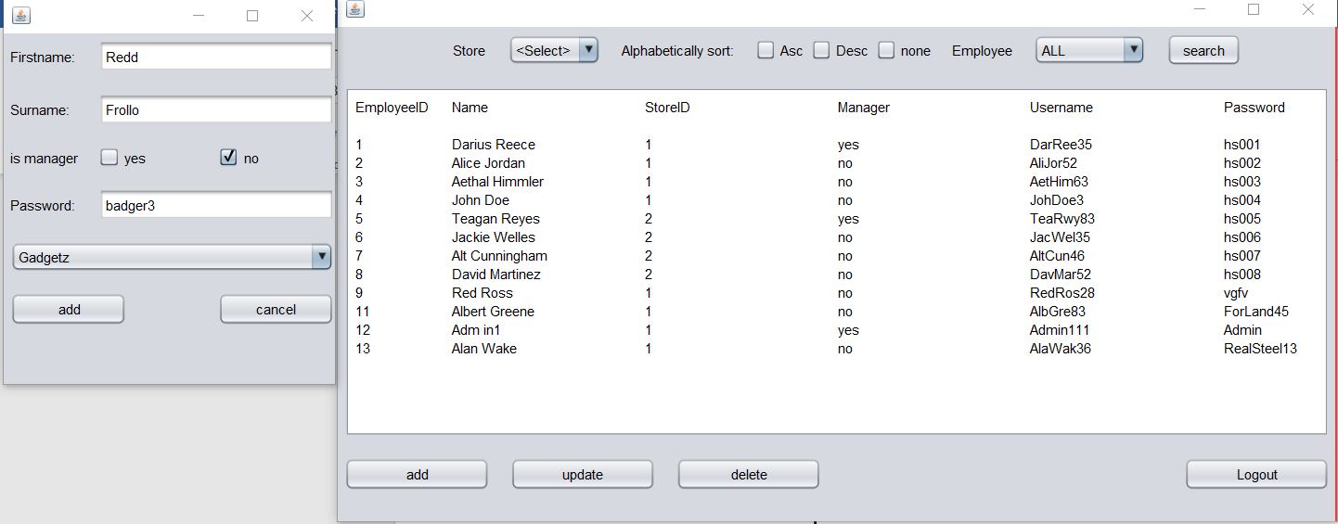Test 1

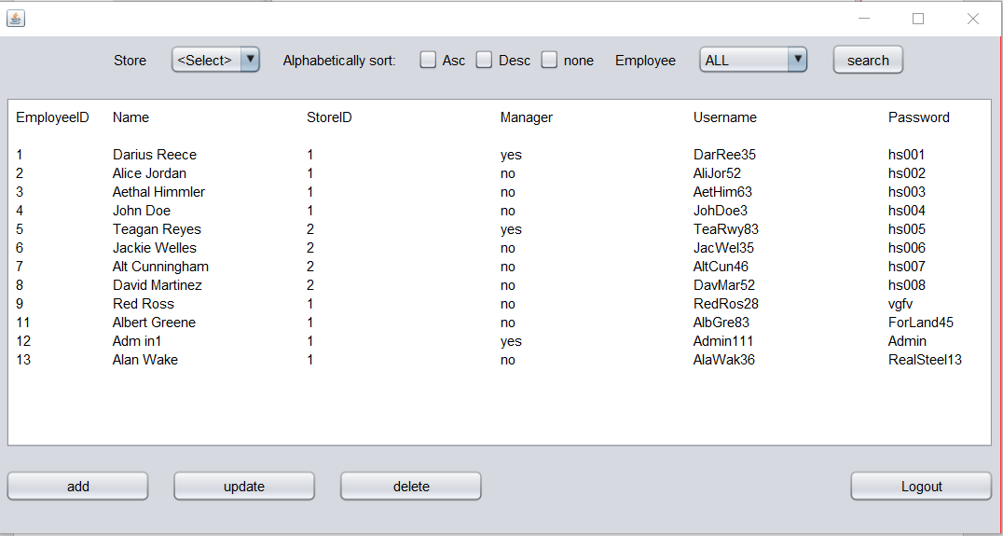Test 2

# Test Plan and Results for TWO input variables

|  |  |  |  |  |
| --- | --- | --- | --- | --- |
| **Test #** | **Input** | **Normal** | **Extreme** | **Erroneous** |
| **1** | Firstname | David | RealHumanNameThatHappensToBeReallyLong | Bo |
| **2** | Password | Realsteel12 | RDDdqcQ12311cczZZaC1341 | n/a |

